Project structure:

An Airflow dag ‘marketvol’ is defined under ‘./airflow/dags’ folder.

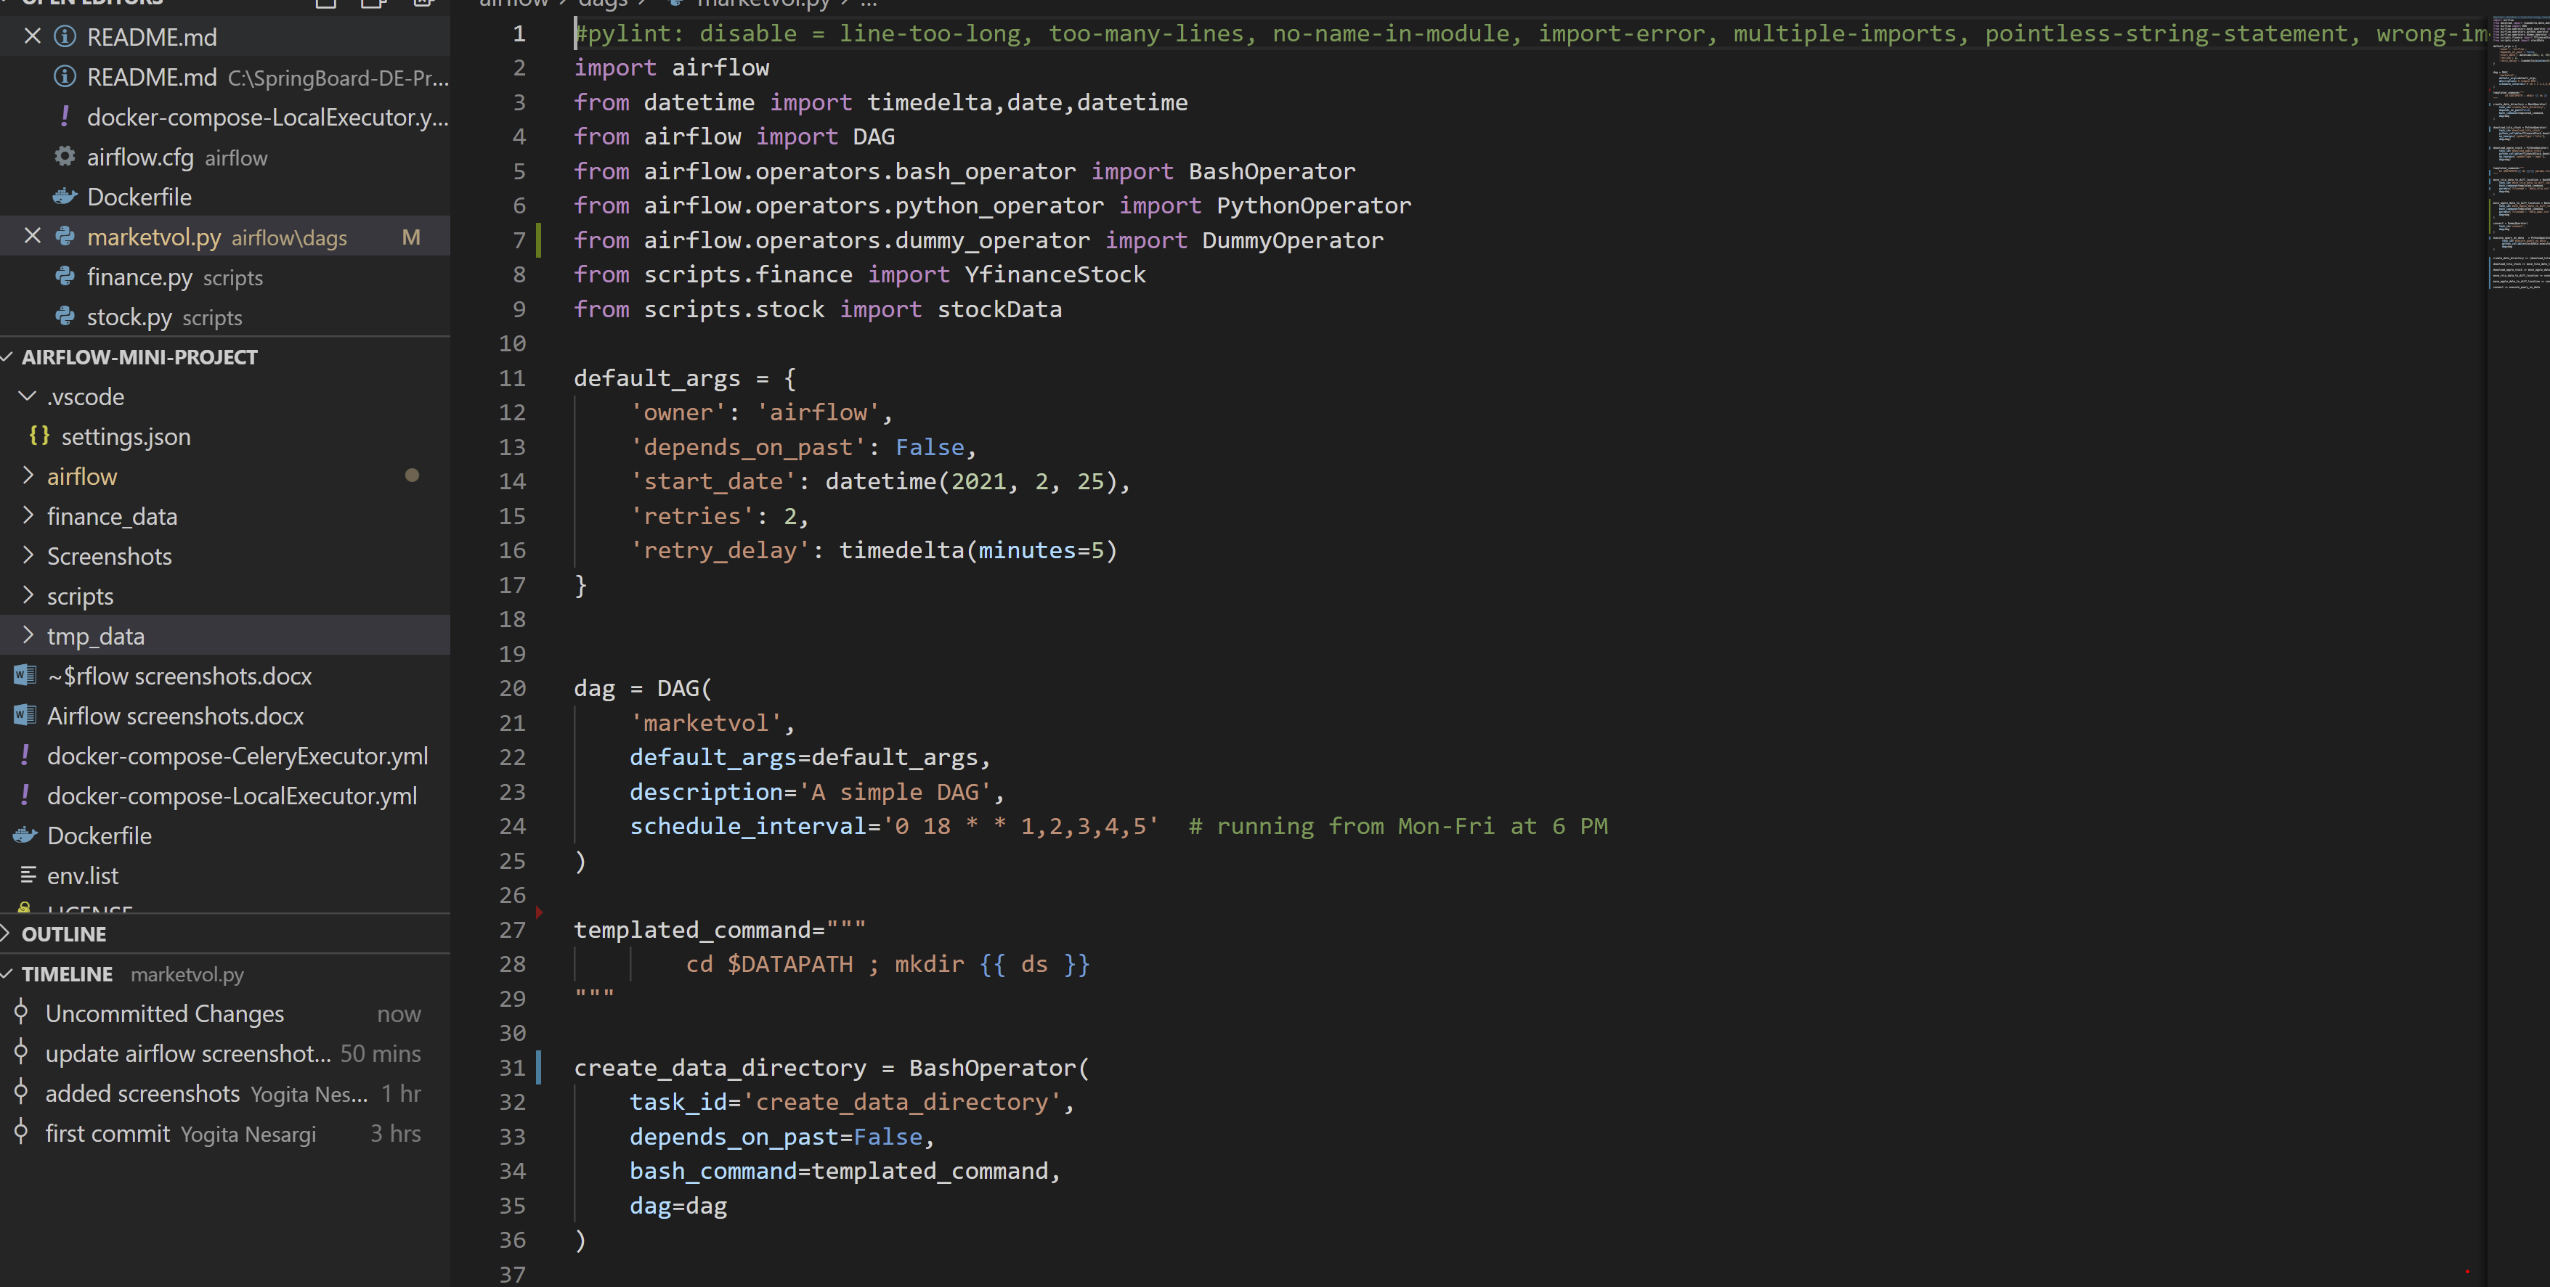

Scripts are under: ‘. /scripts’ folder

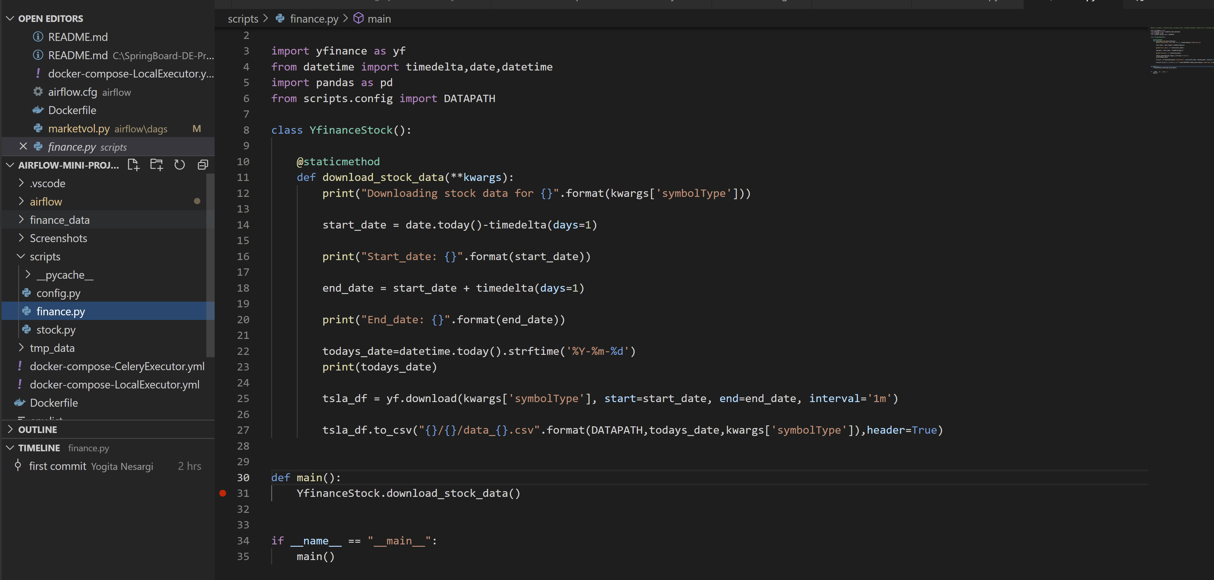

Starting docker container

Command: docker-compose -f docker-compose-LocalExecutor.yml up --build

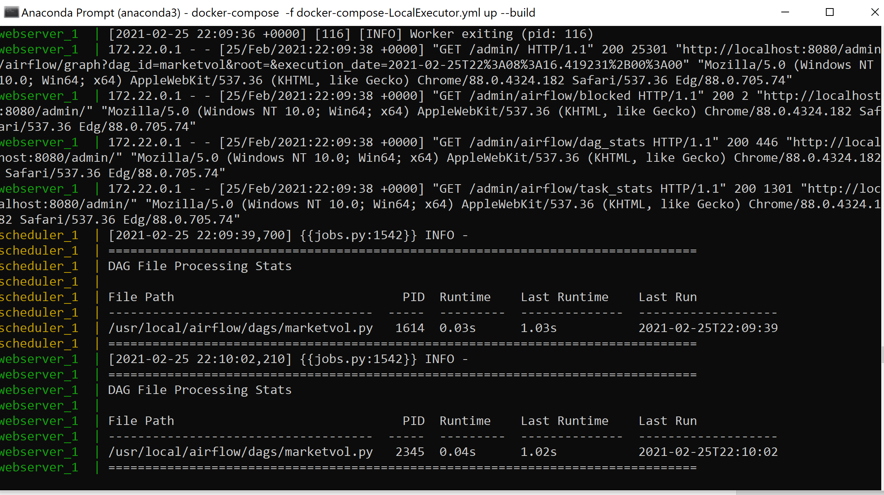

Access Airflow UI using ‘http://localhost:8080’

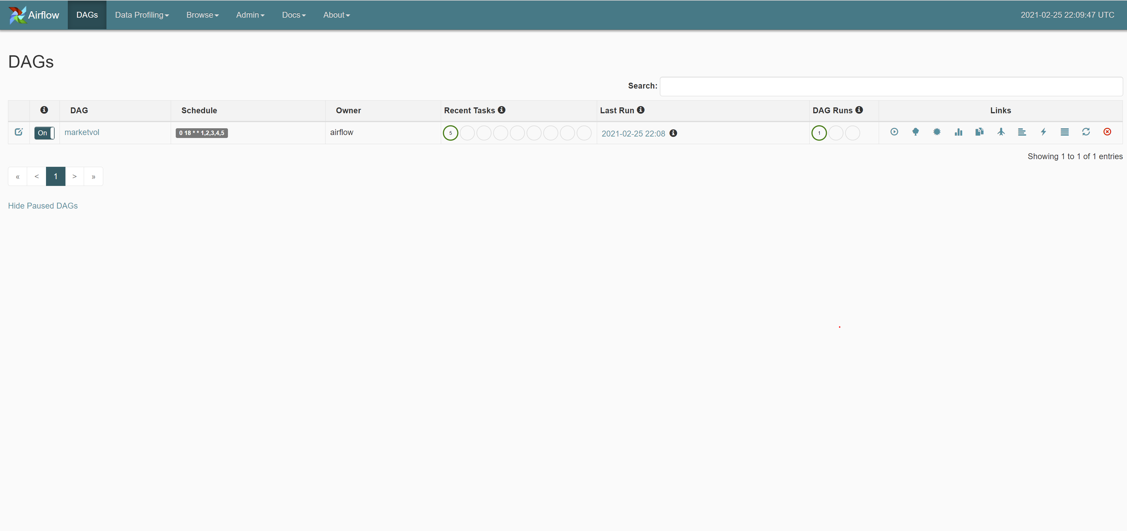

Graph View

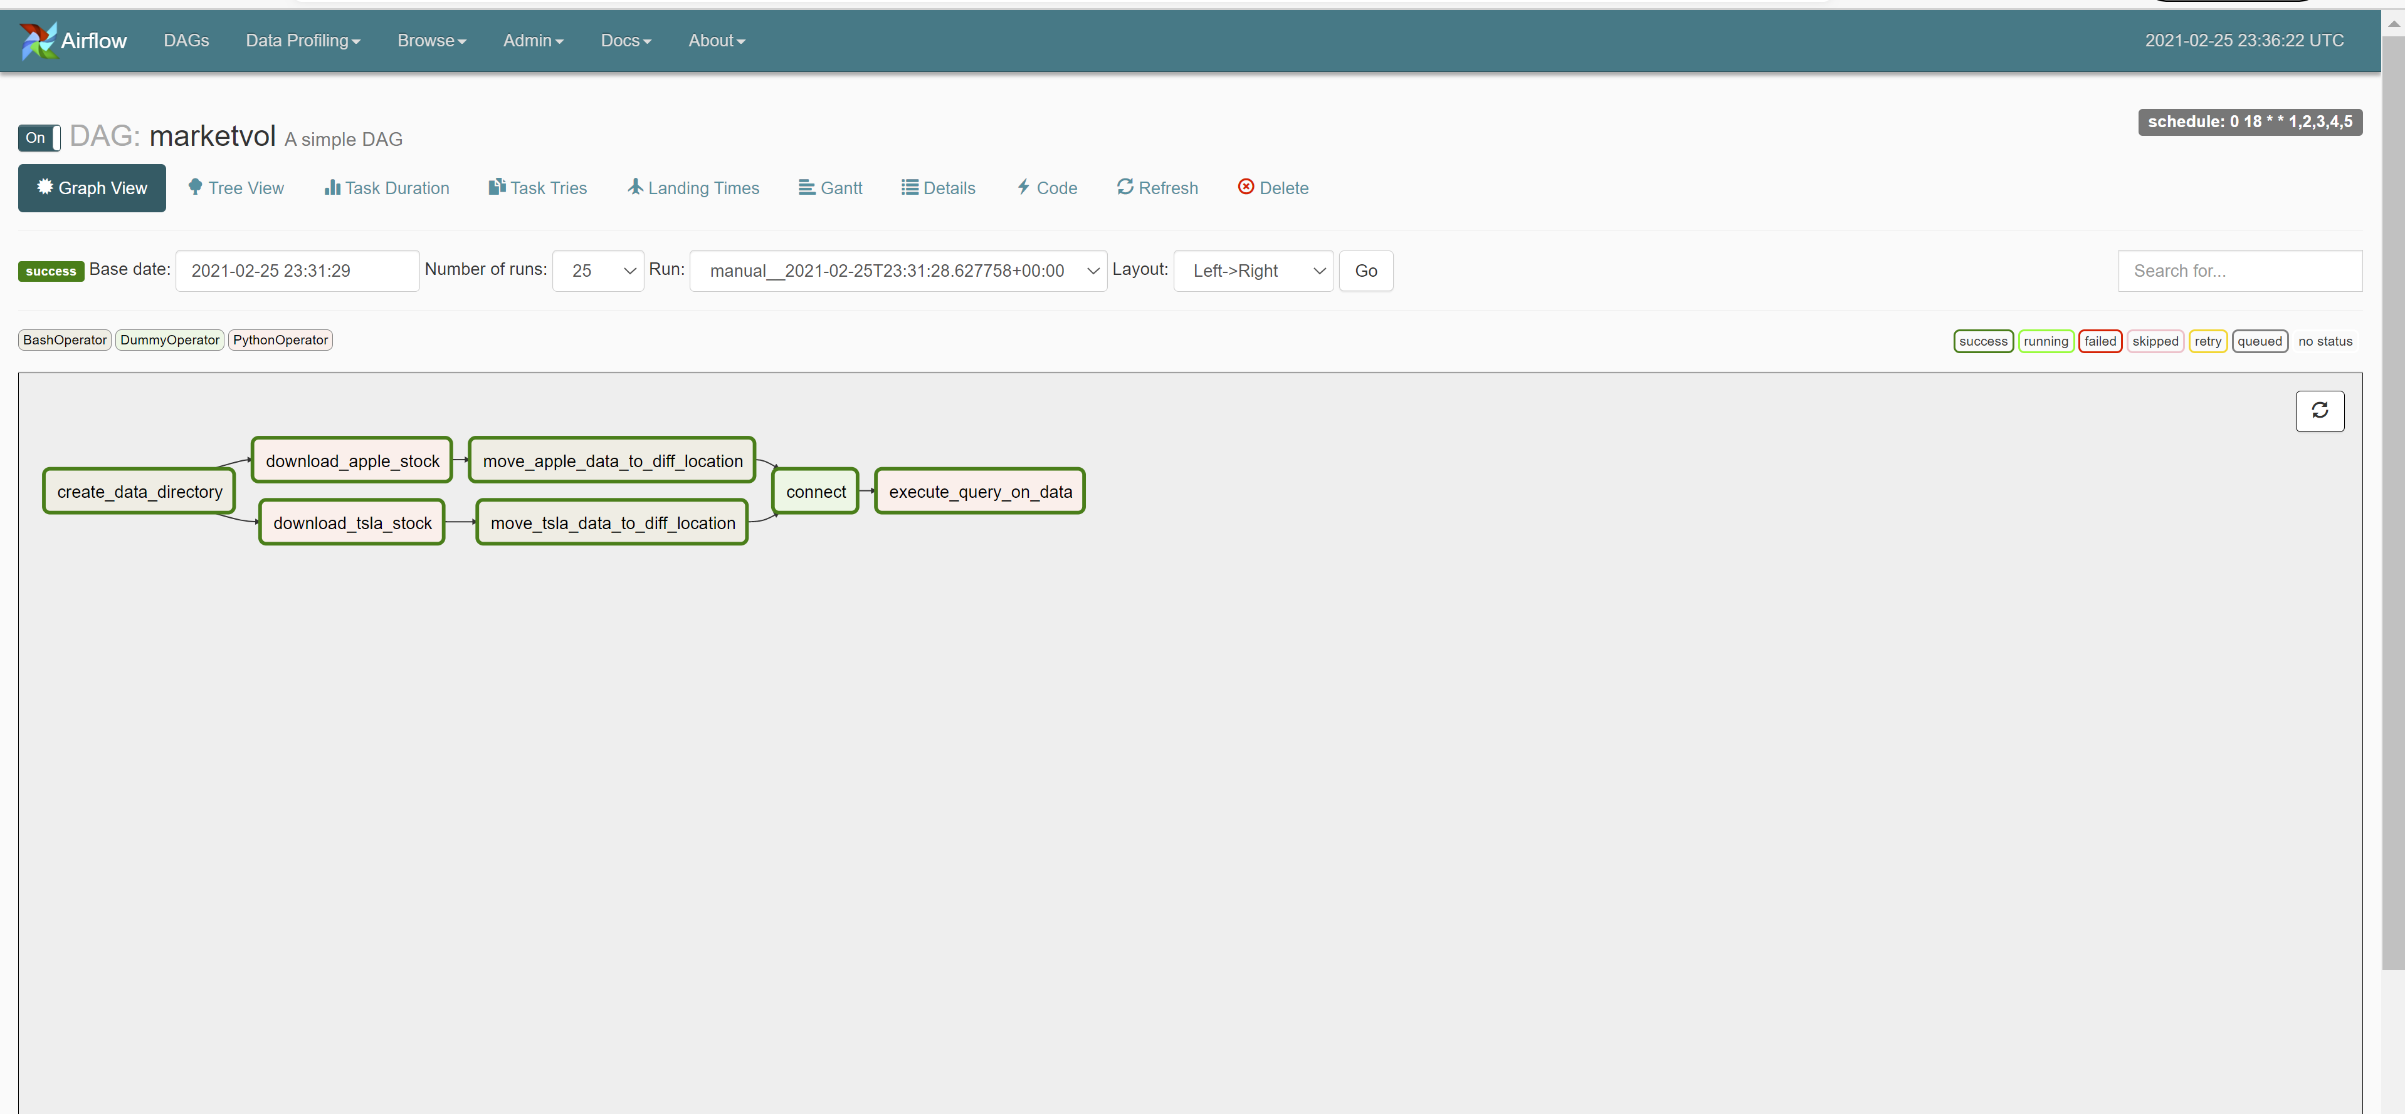

Tree View

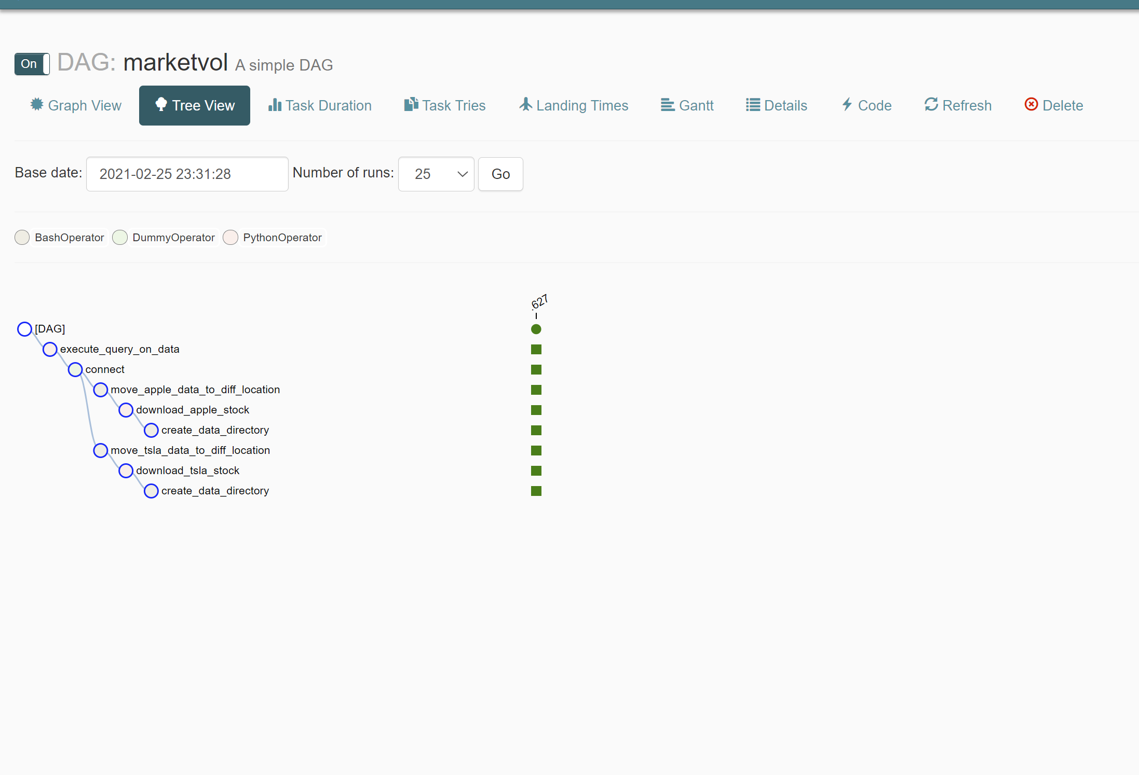

Logs of individual task

Task 1: create_data_directory

The Airflow BashOperator is used to create a directory on current_date: 2021-02-25



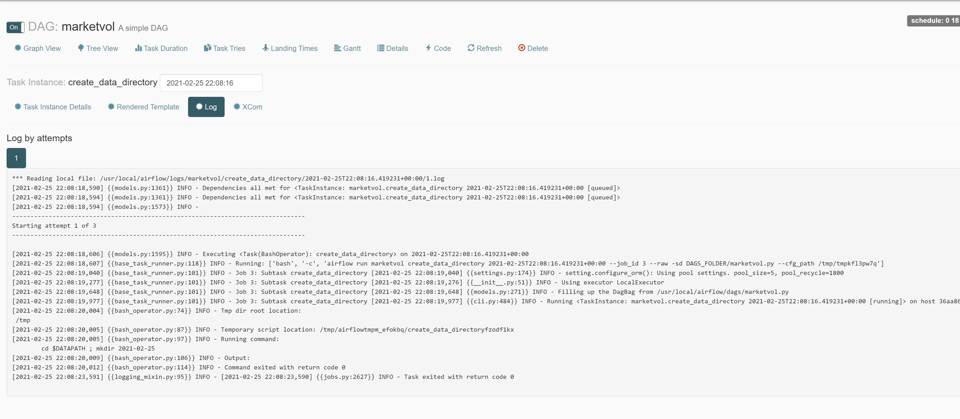

Task 2: download_yahoo_stock

The Airflow PythonOperator is used to download yahoo stock data to temporary path ‘/usr/local/tmp_data/2021-02-25’

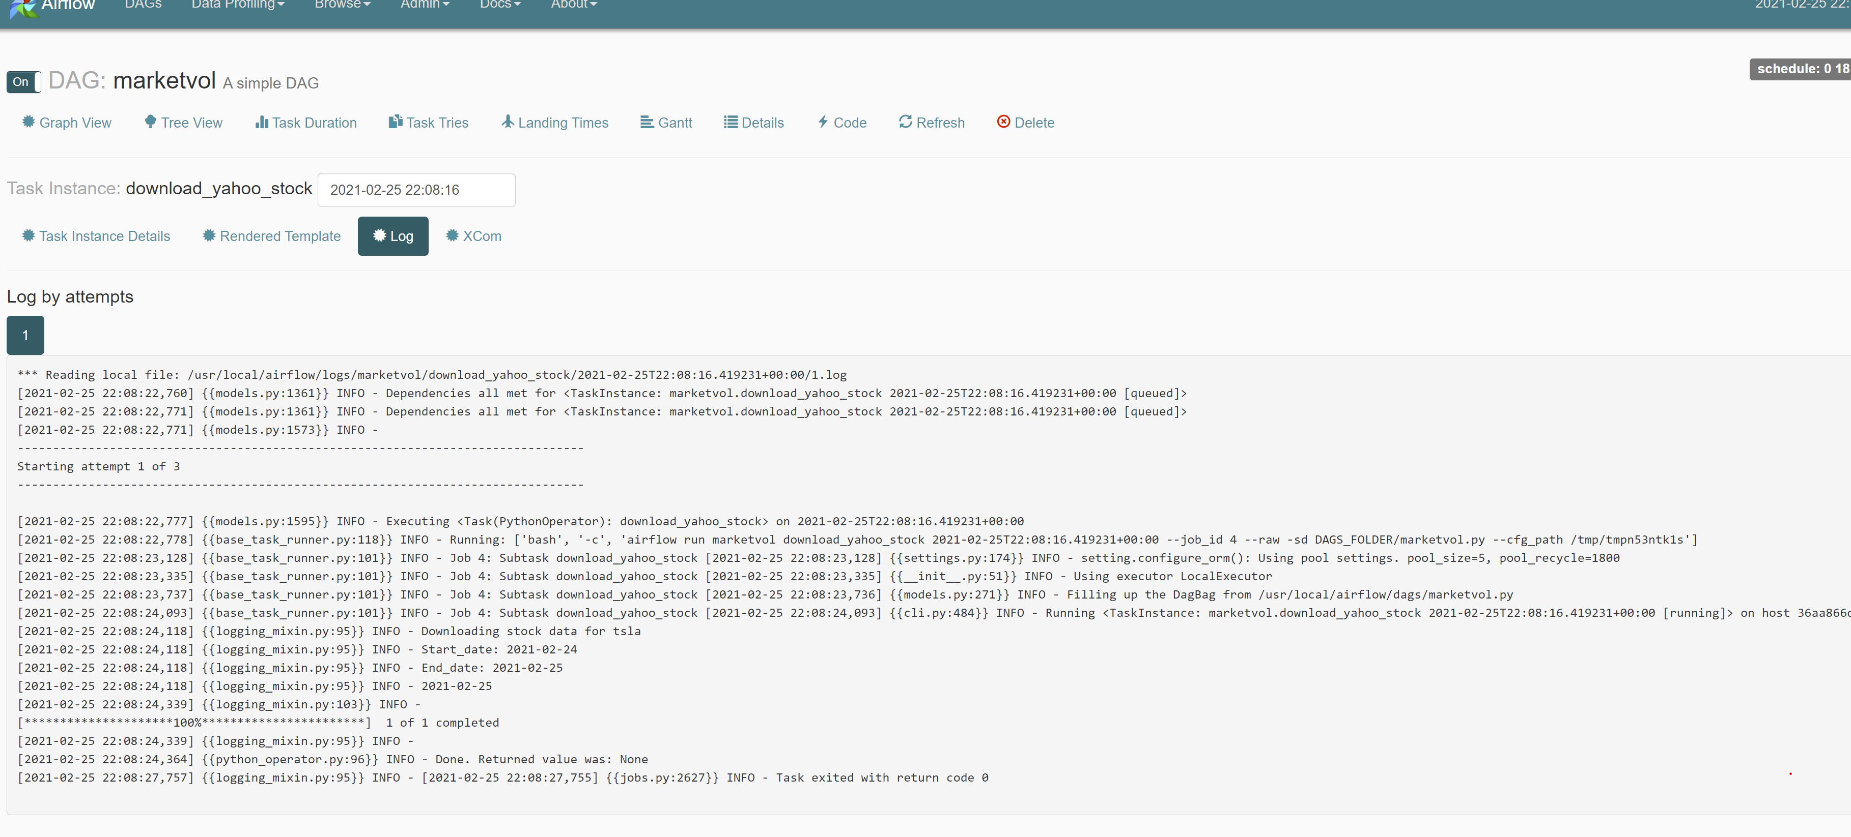

Task 3: download_apple_stock

The Airflow PythonOperator is used to download apple stock to temporary path ‘/usr/local/tmp_data/2021-02-25’

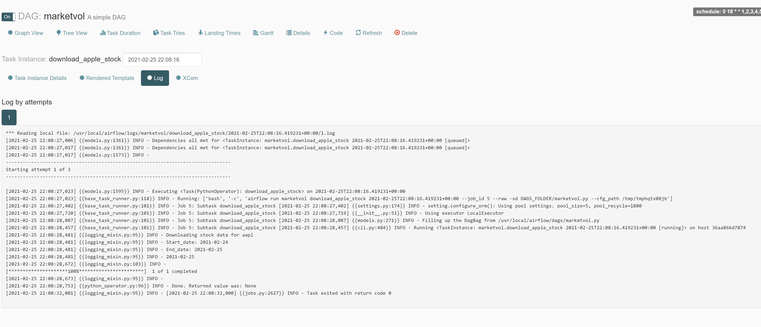

Task 4: move_tsla_data_to_diff_location

The Airflow BashOperator is used to move the data from temporary storage to another location ‘/usr/local/finance_data’

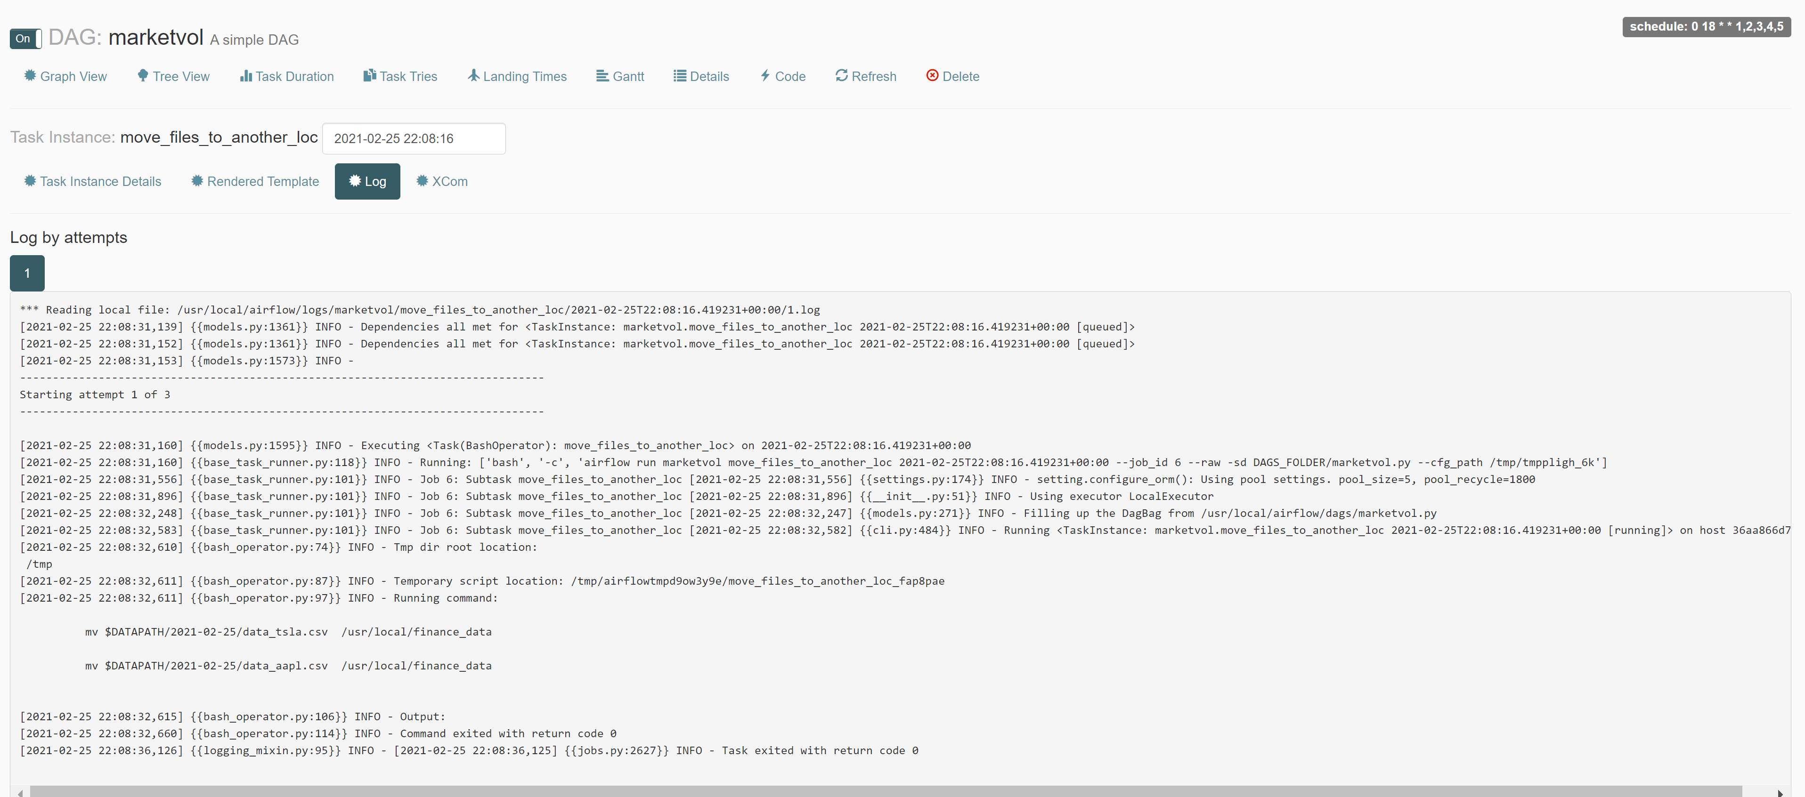



Task 5: move_apple_data_to_diff_location

The Airflow BashOperator is used to move the data from temporary storage to another location ‘/usr/local/finance_data’

Task 6: A dummy operator to connect the two previous task to last task

Task 7: execute_query_on_data

Finally, Airflow ‘PythonOperator’ to run query on the above two dataframes.

